# **Dynacache Implementation**

Step-1: Get tadawul.eportal.common project update from SVN

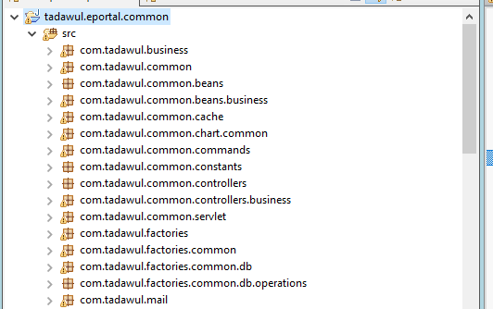

New Package and Class is added to support Dynacache functionality

Class Name: PortalDynacacheUtil.java

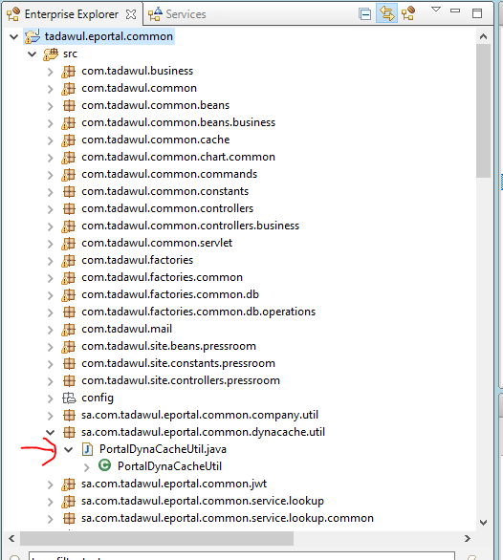

Step-2: Add tadawul.eportal.common project into the build path if not already done

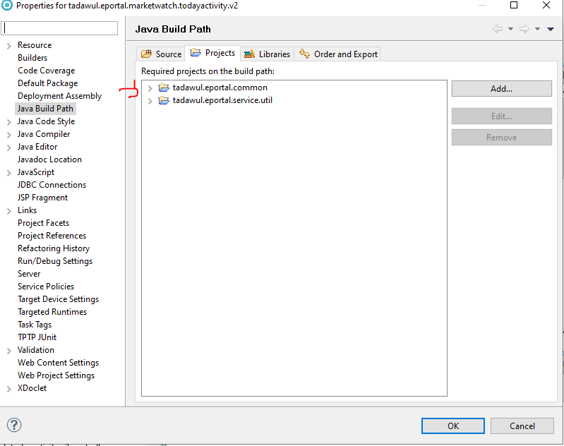

Step-3: Set Page Parameter as below for cache expiration minutes into the respective pages

Page Parameter :

Name : cache.expiry.time.in.minutes

Value (Should be Integer): 5

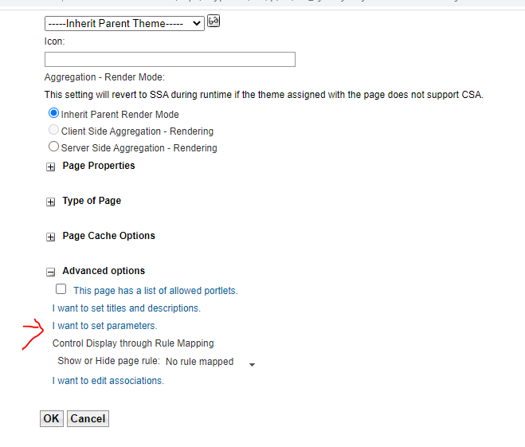

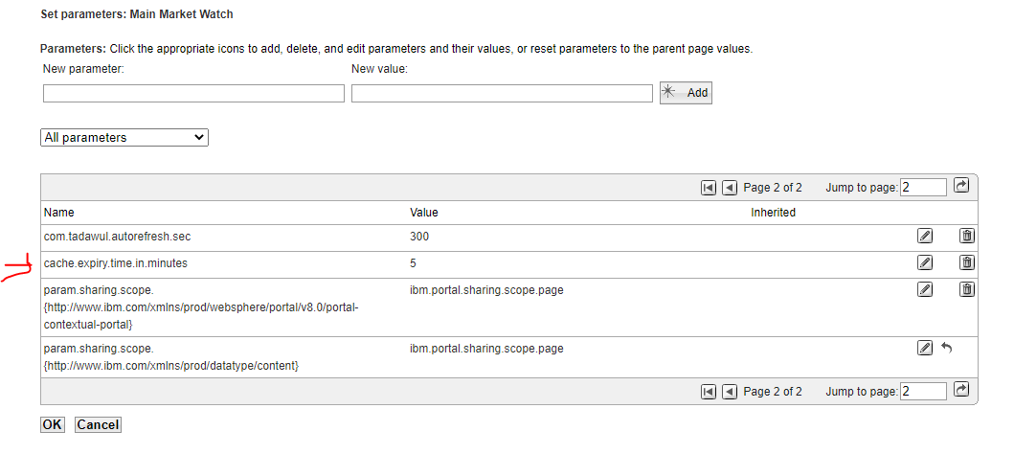

Step-4: Implement Dynacache in the individual portlets

Below are the Detailed steps to elaborate the implementation

1. Check If the cache is not null and key does not contain

**if**(PortalDynaCacheUtil.*getInstance*().getObjectCache() != **null** &&

!PortalDynaCacheUtil.*getInstance*().getObjectCache().containsKey(TodayActivityConstants.*TOPGAIN_MAIN_MARKET_CACHE_KEY*)){

* Then read from DB and insert into the cache

responseList = MarketWatchTodayActivityController.*getTodayActivity*(lang, resourceID, noOfRows, request, response, userID);

PortalDynaCacheUtil.*getInstance*().getObjectCache().put(TodayActivityConstants.*TOPGAIN_MAIN_MARKET_CACHE_KEY*, responseList);

PortalDynaCacheUtil.*getInstance*().getObjectCache().put(TodayActivityConstants.*TOPGAIN_MAIN_MARKET_CACHE_TIMESTAMP_KEY*, **new** Date());

* We need to set two keys 1) cache key 2) cache timestamp

String *TOPGAIN_MAIN_MARKET_CACHE_KEY* = "getTopGainersDetailsCache";

String *TOPGAIN_MAIN_MARKET_CACHE_TIMESTAMP_KEY* = "getTopGainersDetailsCacheTimeStamp";

1. Check whether cache expired based on the configured minutes

if(PortalDynaCacheUtil.getInstance().isCacheTimeStampPassed(cacheTimeStamp, cacheExpiryTimeInMinutes)){

If Expired then insert new cache and cache timestamp

responseList = MarketWatchTodayActivityController.*getTodayActivity*(lang, resourceID, noOfRows, request, response, userID);

PortalDynaCacheUtil.*getInstance*().getObjectCache().put(TodayActivityConstants.*TOPGAIN_MAIN_MARKET_CACHE_KEY*, responseList);

PortalDynaCacheUtil.*getInstance*().getObjectCache().put(TodayActivityConstants.*TOPGAIN_MAIN_MARKET_CACHE_TIMESTAMP_KEY*, **new** Date());

1. If the cache is existing and not expired, then read data from cache

responseList = (List<Stock>) PortalDynaCacheUtil.getInstance().getObjectCache().get(TodayActivityConstants.TOPGAIN_MAIN_MARKET_CACHE_KEY);

Complete Sample Code Reference:

| **if**(PortalDynaCacheUtil.*getInstance*().getObjectCache() != **null** &&  !PortalDynaCacheUtil.*getInstance*().getObjectCache().containsKey(TodayActivityConstants.*TOPGAIN_MAIN_MARKET_CACHE_KEY*)){    *executionContext*.info("getTopGainersDetailsCache cache is null hence inserting into cache ");  responseList = MarketWatchTodayActivityController.*getTodayActivity*(lang, resourceID, noOfRows, request, response, userID);  PortalDynaCacheUtil.*getInstance*().getObjectCache().put(TodayActivityConstants.*TOPGAIN_MAIN_MARKET_CACHE_KEY*, responseList);  PortalDynaCacheUtil.*getInstance*().getObjectCache().put(TodayActivityConstants.*TOPGAIN_MAIN_MARKET_CACHE_TIMESTAMP_KEY*, **new** Date());  }**else**{  Date cacheTimeStamp = (Date) PortalDynaCacheUtil.*getInstance*().getObjectCache().get(TodayActivityConstants.*TOPGAIN_MAIN_MARKET_CACHE_TIMESTAMP_KEY*);  **if**(PortalDynaCacheUtil.*getInstance*().isCacheTimeStampPassed(cacheTimeStamp, cacheExpiryTimeInMinutes)){  *executionContext*.info("getTopGainersDetailsCache cache is not null but current cache expired hence inserting into cache ");  responseList = MarketWatchTodayActivityController.*getTodayActivity*(lang, resourceID, noOfRows, request, response, userID);  PortalDynaCacheUtil.*getInstance*().getObjectCache().put(TodayActivityConstants.*TOPGAIN_MAIN_MARKET_CACHE_KEY*, responseList);  PortalDynaCacheUtil.*getInstance*().getObjectCache().put(TodayActivityConstants.*TOPGAIN_MAIN_MARKET_CACHE_TIMESTAMP_KEY*, **new** Date());  }**else**{  *executionContext*.info("getTopGainersDetailsCache cache is not null and not expired hence reading from cache ");  responseList = (List<Stock>) PortalDynaCacheUtil.*getInstance*().getObjectCache().get(TodayActivityConstants.*TOPGAIN_MAIN_MARKET_CACHE_KEY*);  }  } |
| --- |

Step-5: Track all Dynacache cache keys with page, portlet and functionality. Reference excel is attached

This is required to track the cache mechanism and set proper cache entries into WAS to avoid performance issues.

—--------------------------------------------------------------------------------------------

[4:43 PM, 7/20/2022] Ashish Jha Mrm: Please find attached dynacache implementation document it needs to be implemented on individual portlet of the project.

even if portlet caching is implemented through any other approach replace them with our new approach.

Please Add all dynacache keys in the attached excel sheet - "Dynacache Implementation Cache Keys Reference.xlsx " for whichever portlet you are working on. This is required to properly update cache size in WAS console to avoid performance issue.

Before initiating the implementation of Dynacache Please take latest update from SVN and do not commit the code until your implementation is not successful and verified.

[4:44 PM, 7/20/2022] Ashish Jha Mrm: You need to start it on all tabs of issuer trading information pages for all market and negotiated deals

[4:45 PM, 7/20/2022] Ashish Jha Mrm: Other than dynacche unlimited scroll also needs to be implemented together